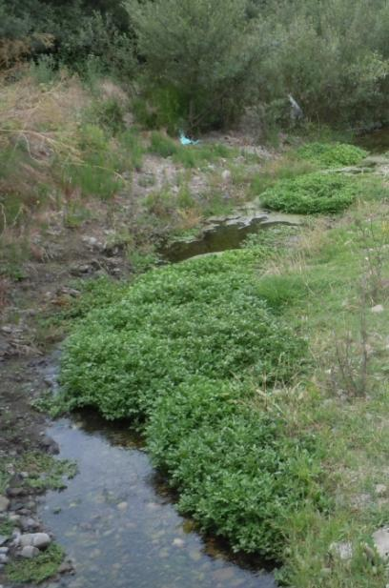
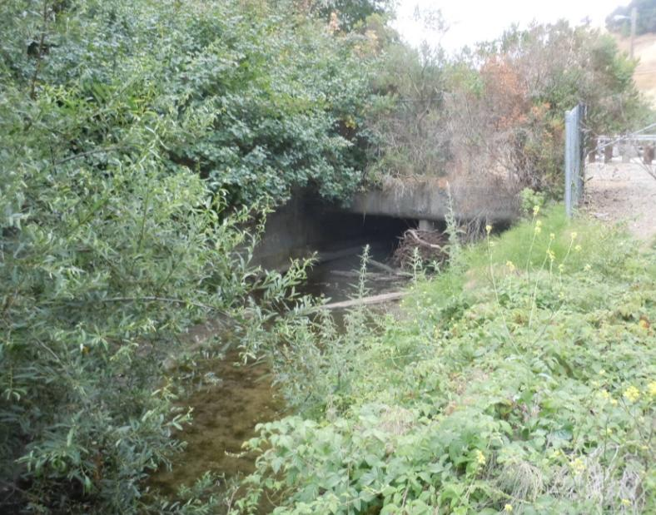

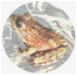
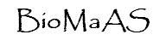
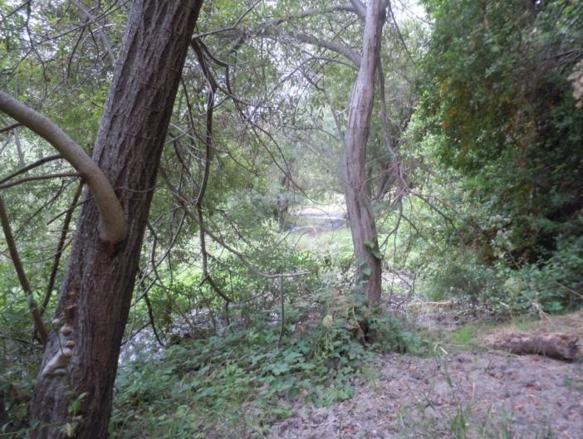
24552 Long Court, Hayward, CA 94545
(510) 265-0747

Prepared for:

Sound Watershed
2201 Melvin Road
Oakland, CA 94602
AND
Alameda County Flood Control and
Water Conservation District
339 Elmhurst Street
Hayward, CA 94544

August 26, 2011
Prepared by:

Biological Assessment

FOR
Eden Canyon Road Box Culvert
De-Silting Project
Alameda County, California
TABLE OF CONTENTS

SUMMARY 1
INTRODUCTION 2
METHODS 6
SETTING 6
VEGETATION COMMUNITIES 7
Riparian Communities / Special-Status Natural Communities 7
Other Communities 8
WILDLIFE HABITATS AND WILDLIFE MOVEMENT CORRIDORS 8
SPECIAL-STATUS PLANT SPECIES 10
SPECIAL-STATUS ANIMAL SPECIES 10
Fish 11
Amphibians 11
Reptiles 12
Mammals 13
Birds 13
WETLANDS AND OTHER WATERS – REGULATORY FRAMEWORK 16
CONCLUSIONS AND RECOMMENDATIONS 17
REFERENCES 19

LIST OF FIGURES
FIGURE
Figure 1. General Location of Study area……………………………………..……...….....3

Figure 2. Regional Location of Study area and Project Footprint……………......……...…4

Figure 3. Special Status Wildlife Species in Project Vicinity……………………………....5

LIST OF TABLES
Table 1. Wildlife species observed during August 6, 2011 survey

APPENDICES
APPENDIX A – Photographs
APPENDIX B – Special-Status Plant Taxa with Some Likelihood of Occurring In Or Near Study Area
APPENDIX C – Special-Status Plant Taxa with Little or No Likelihood of Occurring In Or Near Study Area
APPENDIX D – Special-Status Wildlife Species Obtained From Database/Literature with Potential to Occur In Project Region

SUMMARY
At the request of Sound Watershed on behalf of the Alameda County Flood Control and Water Conservation District (District), BioMaAs, LLC conducted an assessment of biological resources on a 300 ft segment of Eden Canyon Creek east of Castro Valley, Alameda County, California. The study area consists of segments of Eden Canyon Creek 150 feet (ft) upstream and 150 ft downstream of a box culvert under Eden Canyon Road approximately 370 meters north of Interstate 580. The District is proposing to remove accumulated sediment from the box culverts and a total of 300 linear ft of stream in order to restore the creek to its original design capacity and configuration and to reduce the potential for flooding at neighboring properties during major storm events.

Dominant riparian vegetation of the study area is described as riparian, and its potential as habitat for special-status plant and animal species was evaluated. Outside of the riparian vegetation, the site consists primarily of an unpaved access road to the creek on the north side that was mostly devoid of vegetation. Sparse non-native vegetation is present in the disturbed areas on and near the access ramp. The entire study area is surrounded by annual grasslands with occasional stands of oaks.

Based on a literature review and database searches for special-status plant and animal species centered on the Hayward 7.5 minute USGS topographic quadrangle, with data retrieved also for the eight adjacent quadrangles (Oakland East, Las Tramps Ridge, Diablo, San Leandro, Dublin, Redwood Point, Newark, and Niles), a total of 42 special-status plant species and 40 special-status animal species were considered to have a potential to occur in certain types of habitats in the project region.

Following a reconnaissance-level survey of the study area and an assessment of the available habitats onsite, five of the target special-status plant species are considered to have a potential for occurrence onsite; two of the five species could occur upland of the site and outside of the study area while three have the potential to occur within the study area. No target species were observed during appropriately timed botanical surveys.

Of the 40 potentially occurring special-status animal species, 10 have the potential to occur within the study area due to the presence of suitable habitat. Though suitable breeding habitat for California red-legged frog, western pond turtle, and Alameda whipsnake is not present in the study area and vicinity, these species could travel through the study area. Four species of birds including white-tailed kite, sharp-shinned hawk, Cooper’s hawk, and yellow warbler could nest in the study area and vicinity. The trees at the study area could provide maternity roosting sites for three species of bats; yuma myotis, silver-haired bat, and pallid bat.

Below the Ordinary High Water Mark of Eden Canyon Creek is jurisdictional waters of the U.S. subject to regulation by the U.S. Army Corps of Engineers and Regional Water Quality Control Board. In addition to waters of the U.S., riparian vegetation along the creek is identified as a sensitive vegetation community that will fall under the jurisdiction of State regulatory agencies, including the California Department of Fish and Game.

INTRODUCTION
At the request of Sound Watershed and on behalf of the Alameda County Flood Control and Water Conservation District (District), BioMaAs, LLC conducted an assessment of biological resources on a 300 ft segment of Eden Canyon Creek east of Castro Valley, Alameda County, California (Figures 1 and 2). This Biological Resources Analysis summarizes the results of the field survey and analysis of potential impacts on biological resources with a focus on special status plant and wildlife species and sensitive habitats. In addition, this report provides recommendations for avoidance, and measures to reduce impacts to special status wildlife and/or their habitat. The study area consists of segments of Eden Canyon Creek 150 feet upstream and 150 ft downstream of a box culvert under Eden Canyon Road approximately 370 meters north of Interstate 580.

The District is proposing to remove accumulated sediment from the box culverts and 300 linear ft by a 30 ft wide segment (9,000 sq. ft./ 0.21 acre) of stream in order to restore the creek to its original design capacity and configuration and to reduce the potential for flooding neighboring properties during storm events. The twin 10 ft by 8 ft box culverts are nearly ¾ full of accumulated sediment. Temporary cofferdams and a water diversion pipeline would be installed to re-route water around the work area. Cofferdams would be constructed using clean river run gravel wrapped in plastic or sand bags wrapped in plastic. The cofferdams would result in the temporary placement of 26.7 cubic yards of earthen material on the bottom of the flood control channel and would temporarily impact 0.1 acres. Upon completion of the project, the cofferdams would be removed and hauled to an upland disposal site. Approximately 1,500 cubic yards of debris and sediment would be removed from the channel using an excavator, truck, crane, generator, power hand tools, and/or manual hand tools. No work in the creek would occur until the creek has been completely dewatered.

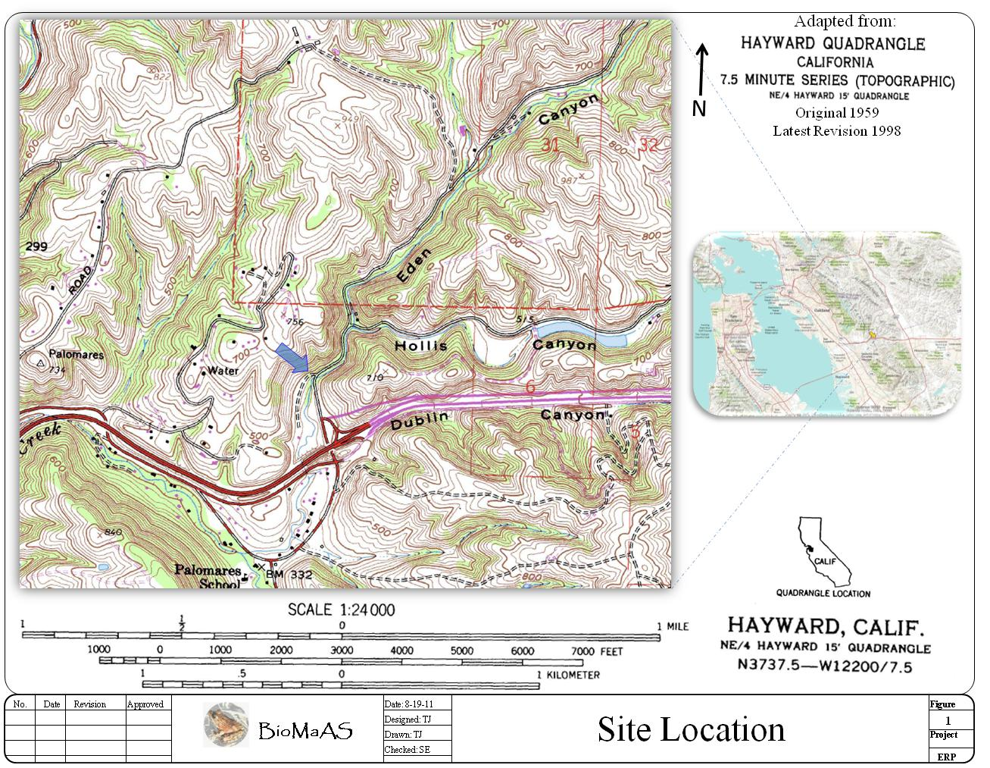

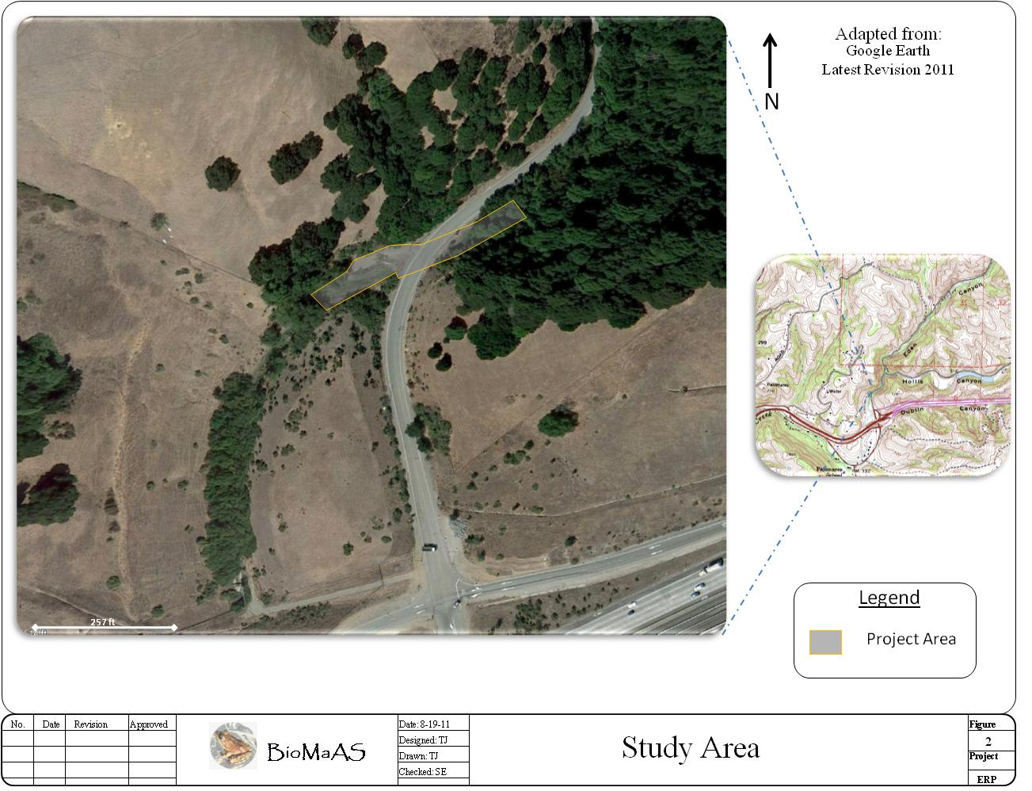
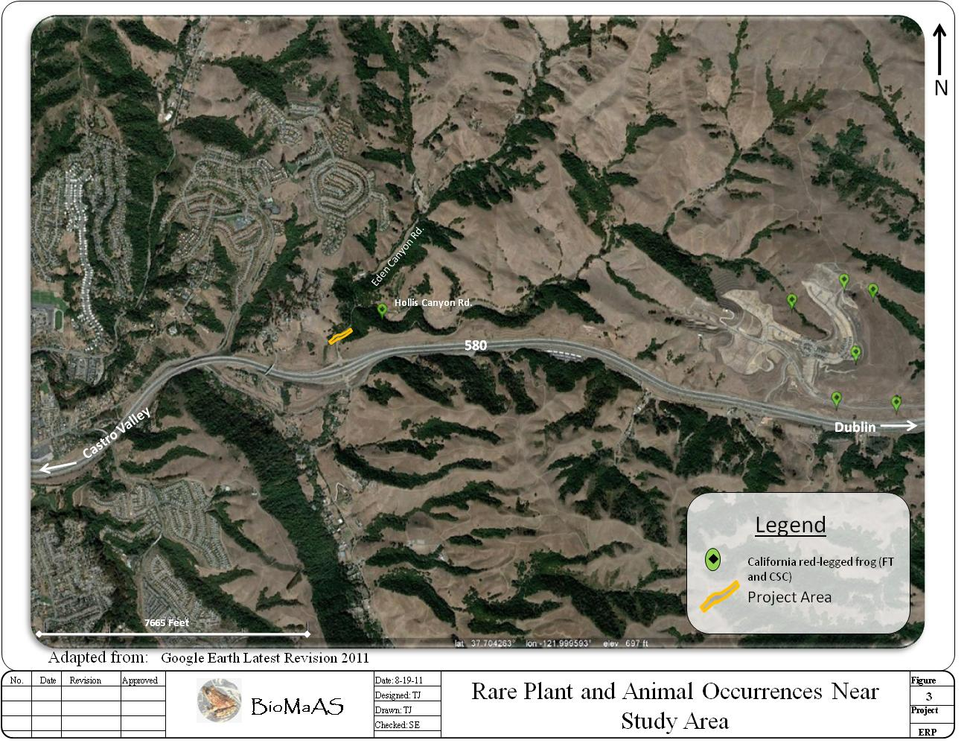

METHODS
An initial biological reconnaissance of the study area was conducted by BioMaAS biologist’s Sandra Etchell and Tony Jones, independent biologists Debbie Peterson (botany) and Sam McGinnis (reptiles, amphibians and fish) on August 6, 2011. The entire study area was surveyed on foot, and all distinct vegetation communities were visited and described. In addition, focused special-status plant and animal surveys were conducted as part of our reconnaissance.

Information on special-status plants, animals, and vegetation communities was compiled through a review of references published by the California Department of Fish and Game (CDFG 2011a, b), and the California Native Plant Society (CNPS 2011), U.S. Fish and Wildlife Service (USFWS 2011).

SETTING
Eden Canyon Creek is the primary drainage for Eden Canyon located north of Interstate 580 between Castro Valley and Dublin, California. It is represented as a permanent creek on USGS topographic maps, and in midsummer, 2011 exhibited a slow but steady flow in the segment adjacent to its passage beneath Eden Canyon Road at mile marker 0.46. Approximately 0.5 miles north of this point it receives an intermittent drainage from Hollis Canyon. For many years this tributary was dammed within the canyon to form a long, narrow ranch pond, but earlier in this century it was either purposely drained or the dam blew out, with the result that the winter flow through this drainage proceeds uninhibited to Eden Canyon Creek. From Eden Canyon road the creek flows southwest towards I-580 where it passes down a steep 15 ft high drop structure before passing through a large culvert under the highway. It then flows west parallel to I-580 to its confluence with San Lorenzo Creek just west of the I-580/Crow Canyon Road junction.

Upstream from the proposed study area the creek course is well shaded by a dense tree canopy, but immediately downstream from Eden Canyon Road the greater creek bank area contains heavy silt deposits and no tree canopy (See Appendix A - Photos #1 & #2). Creek depth within the study area ranges from a few inches to about one foot. However, deposits of wood debris and trash well up on the creek banks indicate depths of at least several feet during the height of midwinter runoff flows (See Appendix A – Photo #3).

Eden Canyon Creek in the study area as described above covers a little more than one-quarter acre. The study area boundary is shown in Figure 2. The creek channel is flanked by a steeply sloped hill above the north bank, and a moderately slope bank to the south. The upland terrain surrounding the creek consists of non-native grassland with occasional stands of oak trees.

The location is about one tenth of a mile north of I-580, within Township T3 South, Range 1 West, Section 24 on the Mt. Diablo Meridian and Baseline. The site appears on the Hayward USGS 7.5-minute quadrangle.

Topography of the site where the creek is situated is hilly terrain. Elevations onsite range from approximately 415 ft above sea level at the east end to about 380 ft at the west end. The creek flows through the study area in a more or less southwesterly direction.

VEGETATION COMMUNITIES
For plant communities and special-status plant species, the study area included the riparian zone 150 feet above and 150 feet below the box culvert under Eden Canyon Road plus, for encroachment needed beyond the riparian area, an assessment of the areas adjacent to the riparian zone along both sides of that stretch of the stream.

Despite the small extent of the study area, six plant communities were present and include riparian, woodland, grassland and two types of the chaparral often referred to as coastal or soft scrub. The vegetation in these plant communities is classified below according to the types published in the Hierarchical List of Natural Communities with Holland Types (CDFG 2010).

Riparian Communities / Special-Status Natural Communities

Special-status natural vegetation communities are those that are considered rare in the region, support special-status plant or wildlife species, or receive regulatory protection under Section 404 of the federal Clean Water Act or Section 1600, et seq. of the California Fish and Game Code. The California Natural Diversity Data Base (CNDDB) has designated a number of communities as rare or sensitive and these communities are given the highest inventory priority (CNDDB 2011b).

Riparian habitats are considered by State and federal regulatory agencies to represent a sensitive and declining resource. Wetlands and riparian areas often serve important biological functions by providing nesting, breeding, foraging, and spawning habitat for a wide variety of resident and migratory wildlife species

Upstream or northeast of the box culvert under Eden Canyon Road, dense riparian forest covers the entire hillside to the south of the stream. It was dominated by California bay (Umbellularia californica) with some coast live oak (Quercus agrifolia), big-leaf maple (Acer macrophyllum), and a few blue elderberry (Sambucus mexicana). This community can be classified under California Natural Community Code (CaCode) 74.100.05, Umbellularia californica-Quercus agrifolia/Toxicodendron diversilobum. On the north side of the upstream side, next to the road, were several large trees of red willow (Salix laevigata) and, where the canopy opened up, a dense patch of Himalayan blackberry (Rubus discolor) and stinging nettle (Urtica dioica). This community can be classified as CaCode 61.205.01, Salix laeviata (Red Willow Alliance).

Downstream, running southwest from the box culvert, the red willow community continues within the riparian zone. The vegetation on this side included thickets of small-diameter red willow scrub on the south side of the stream, changing to larger, more distinct willow trees on both sides of the stream at about 150 feet downstream. This community is, again: CaCode 61.205.01, Salix laevigata. The north bank on this side of the culvert consisted mainly of a large sand bank and no distinct plant community, with evidence of a large rush of water through this stretch last winter. Closest to the stream was a sparse mixture of native and non-native wetland-type plants, including iris-leaved rush (Juncus xiphioides), spiny clotbur (Xanthium spinosum), tall flatsedge (Cyperus eragrostis), horsetails (Equisetum sp.), bentgrass (Agrostis sp.), rabbit-foot grass (Polypogon monspeliensis), and strawberry clover (Trifolium fragiferum). Higher up, including on top of the sandbar, were mostly weedy exotic plants, including shortpod mustard (Hirschfeldia incana), ripgut brome (Bromus diandrus), soft chess (Bromus hordeaceus), Italian thistle (Carduus pychnocephalos), and jimson weed (Datura stramonium). Within the stream itself were large patches of water cress (Rorippa nasturium-aquaticum).

Both riparian communities mentioned are considered special-status natural communities due to their limited distribution in California (CDFG 2009), even if they do not contain special-status plant species.

Other Communities

Upstream from the box culvert, on the north side and across the road, was a steep bank covered by California sagebrush and sticky monkey flower (CaCode 32.010.11, Artemisia californica-Diplacus aurantiacus).

Downstream from the box culvert, on the north side the willow community transitioned into coast live oak woodland containing scattered bay laurel trees (CaCode 71.060.50, Quercus agrifolia-Umbellularia californica) and open stretches of exotic annual grassland (primarily CaCode 42.026.22, Bromus diandrus-Avena spp.). There was also a small patch of coyote brush and California sagebrush scrub (CaCode 32.060.05, Baccharis pilularis-Artemisia californica). On the south side, willow thickets transitioned into willow trees and then exotic annual grassland.

WILDLIFE HABITATS AND WILDLIFE MOVEMENT CORRIDORS
Wildlife species expected onsite are those typically associated with riparian habitats, although a lack of pools or open water makes the site much less attractive to certain species. In addition, the lack of suitable aquatic habitat limits the site for residence or breeding activities of some animals, such as California tiger salamander (Ambystoma californiense). However, the moderately dense vegetative cover provided by the riparian canopy does offer significant nesting and foraging opportunities for a number of bird species and potential for bat maternity roosts.

Native species such as black-tailed deer, coyote, grey fox (Urocyon cinereoargenteus), and raccoon (Procyon lotor), and the non-native red fox (Vulpes vulpes), are some of the larger mammals that are likely to use the study area for foraging or cover. It is feasible that Eden Canyon Creek could be utilized as a movement corridor for wildlife although it is in close proximity to urban development and the heavily trafficked I-580. However the project is temporary in nature and would not permanently disrupt wildlife movement through the area.

Table 1 provides a list of wildlife species observed during the August 6, 2011 reconnaissance-level survey.

TABLE 1. Wildlife Observed During August 6, 2011 Survey
Common Name | Scientific Name
Amphibians
California newt | Taricha torosa
Pacific chorus frog | Pseudacris regilla
Birds
Turkey vulture | Cathartes aura
White-tailed kite | Elanus leucurus
Red-tailed hawk | Buteo jamaicensis
Wild turkey | Meleagris gallopavo
Gull | Larus ssp.
Mourning dove | Zenaida macroura
Stellar’s jay | Tachycineta bicolor
Scrub jay | Cyanocitta stelleri
Bushtit | Psaltriparus minimus
Bewick’s wren | Thryomanes bewickii
Dark-eyed junco | Junco hyemalis
Other Mammals
Coyote | Canis latrans
Black-tailed deer | Odocoileus hemionus

SPECIAL-STATUS PLANT SPECIES
References consulted for potential presence of special-status plant species included the California Natural Diversity Data Base (CNDDB 2011b) and California Native Plants Society's online Inventory of Rare, Threatened and Endangered Plants (CNPS 2011). Database searches were centered on the Hayward 7.5 minute USGS topographic quadrangle, with data retrieved also for the eight adjacent quadrangles (Oakland East, Las Tramps Ridge, Diablo, San Leandro, Dublin, Redwood Point, Newark, and Niles). For the purposes of this assessment, special-status plant species were defined as species with federal or state listing of threatened or endangered and/or CNPS rare plant classifications of 1B or 2. Thus defined, the searches produced a list of 42 special-status vascular and non-vascular plant species, of which 19 were deemed to have some likelihood, based on habitat requirements and known distributions (see APPENDIX A and B). Of these 19 species, 7 would definitely have been identifiable at time of the survey, which was conducted on August 6, 2011. None of the special-status plant species were detected. Of the 19 species, all but 2 (Juglans hindsii and Mondardella villosa ssp. globosa) were not likely to be found in or near the riparian zone at all, but in the surrounding upland areas and, even then, the presence of most of these species is only a remote possibility. A brief additional survey toward the end of April, mainly downstream from the box culvert and on the north side of the stream, would settle questions about presence or absence of the remainder of the more likely special-status species.

SPECIAL-STATUS ANIMAL SPECIES
Special-status animal species include those listed as Endangered, Threatened, Rare, or as Candidates for listing by the USFWS (2011a) and/or CDFG (2011b). Other species regarded as having special-status include special animals, as listed by the CDFG (2011). Other species regarded as having special status include “special animals”, as listed by the CDFG (2011). Additional animal species receive special protection under the federal Bald and Golden Eagle Protection Act and the federal Migratory Bird Treaty Act. The Fish & Game Code of California provides protection for “fully protected birds”, “fully protected mammals”, “fully protected reptiles and amphibians”, and “fully protected fish”. Federal Species of Concern is not defined in the federal Endangered Species Act of 1973; however, USFWS maintains a website (Environmental Conservation Online System, http://ecos.fws.gov/tess_public/) which lists plant and wildlife species that are declining or appear to be in need of conservation and designates species of special concern or a similar status.

Based on our review of the California Natural Diversity Data Base (CNDDB 2011a) and our knowledge of the geographic range and habitat affinities of special-status animals, a total of 40 special-status animal species were considered in this analysis to have the potential to occur within the project region. Only one was detected during the current study, however, several are considered to have at least some potential to occur onsite. A summary of the formal status, habitat affinities, and potential for occurrence within the study area for each of the target animal species is presented in Appendix C. Based upon the types of habitat that each listed species occupies, and on observations made during the August 2011 site survey, each wildlife species was evaluated for its potential to occur in the vicinity of the Study area. If the possibility of occurrence of some species was eliminated, the table includes a brief discussion of how this assessment was derived. Only species considered to have potential to occur or having suitable habitat present are briefly discussed in the following section.

Fish

The clear, shallow water of Eden Canyon Creek during the summer survey period permitted excellent viewing of both vertebrate and invertebrate aquatic life, but no fish species were seen. This is somewhat unusual for non-polluted segments of East Bay creeks, where common native species such as the threespine stickleback, Gasterosteus aculeatus, and the California road, Lavinia symmetricus, a California Species of Special Concern (CSSC) are often present. Indeed, even the widely introduced mosquitofish, Gambusia affinis, was also absent in the survey area. The complete absence of fish is due to the formidable 15 foot high drop structure that was constructed in the creek course just before its passage beneath I-580 (See Appendix A - Photo #4). There were very likely one or more fish species inhabiting the creek segment upstream from this structure before its construction but one or more heavy winter flows the following years carried all fish present to downstream areas. A normal post-winter flow scenario for such creeks is one where some displaced fish gradually move back upstream during the summer low flow period and re-colonize such areas.

Steelhead
Steelhead (Onchorhyncus mykiss irideus), Central California Coast ESU, federally listed as threatened, spawns in gravelly substrate in streams from the Russian River to just south of Soquel Creek, as well as tributaries to the San Francisco Bay. The nearest CNDDB record (occurrence 2) for steelhead to the Eden Canyon Creek De-silting Study area is for steelhead captured in 1999 in Alameda Creek in Niles Canyon, approximately 8.25 miles southeast. Steelhead that historically spawned in the upper reaches of most East Bay permanent creeks, including San Lorenzo Creek and some of its tributaries are not expected to be found in Eden Canyon Creek due the 15-ft high drop structure which now prevents steelhead access to the upstream area.

Amphibians

Numerous larvae of the Pacific chorus frog, Pseudacris regilla, along with two larvae of the California newt, Taricha torosa, were observed in the shallow, clear water downstream from the Eden Canyon Road culvert. Both species are late spawners and apparently take advantage of the small side pools that are left after the heavy winter flows subside. One such small pool is present under the stranded plastic debris shown in Photo #3 in Appendix A.

California red-legged frog
No larvae or adults of the California red-legged frog, Rana draytonii, a federally threatened species, were observed. The high winter flows would negate successful spawning for the California red-legged frog which lays its large egg masses in late January and February when strong currents would wash them downstream. This frog is highly dependent on deep creek pools for retreat from predators, and none exist in the greater study area. The adult California red-legged frog is known for its occasionally wandering up to about two miles from a breeding pond, and thus a slight possibility exists that one could pass through the study area during the desilting work. However, the only possible source for such a wanderer listed in the CNDDB (occurrence 580) is the pond that was once present in Hollis Canyon but no longer exists.

Foothill yellow-legged frog
No larvae or adults of the foothill yellow-legged frog, Rana boylii, a CSSC, were seen. The larvae of these ranid frogs are readily identified by the position of the eyes inside the outer margin of the head as opposed to protruding from the head margin as with Pacific chorus frog larva. They both undergo metamorphosis in August in the Inner Coast Range, and large mature tadpoles should be seen if present. The foothill yellow-legged frog spawns later in April or early May but requires extensive rock rubble in a creek basin between which to secure its grape-like egg clusters, but the spaces between the small amounts of such rubble in Eden Canyon Creek that is present has been filled with silt. This frog is also highly dependent on deep creek pools for retreat from predators, and none exist in the greater study area. The nearest CNDDB record (occurrence 790) for foothill yellow-legged frog to the Eden Canyon Creek De-silting Study area is over 13 miles to the east.

California tiger salamander
California tiger salamander (Ambystoma californiense), federally listed as threatened, and recently listed as a California threatened species within the project region, breeds in eutrophic ranch ponds and intermittent creek pools in the Pleasanton and Livermore Valleys. It spawns in midwinter when heavy flows such as those in Eden Canyon Creek would most likely wash eggs downstream. The larvae undergo metamorphosis throughout the summer, and some would have been detected if present. The metamorphs and adults spend up to eleven months of the year in deep ground squirrel burrows, but no ground squirrel burrows are present in the uplands adjacent to the study area. The nearest CNDDB record (occurrence 674) for California Tiger Salamander to the Eden Canyon Creek De-silting Study area is for eggs, larvae, and juveniles observed in 2004 beyond the hills between Castro Valley near Dublin and San Ramon in a seasonal wetland on federally owned land approximately 8 miles east of the study area. There are numerous CNDDB records for this species in that vicinity. No suitable habitat for California tiger salamander is present in the study area.

Reptiles

Western pond turtle
Western pond turtle (Emys marmorata), a CSSC, inhabits permanent water of ponds, marshes, rivers, and streams, and requires sunny basking sites and sandy banks or grassy open fields for laying eggs. The pond turtle could possibly pass through the study area on a rare occasion. The turtle is a long distance wanderer and could conceivably migrate upstream and around the drop structure from some pond habitat west of the study area. The nearest CNDDB location recorded (occurrence 201) is for a pond turtle observed in 2000 swimming in a scoured pool in Bolinas Creek approximately 4 miles north of the study area. It is unlikely that western pond turtle would inhabit the study area because the deep pools and fish prey that they require are not present in the study area thus their occurrence at the site would be a very rare and brief event. Occurences of the species have been documented with in the vicinity of the study area to the east (See Figure 3).

Alameda striped racer (Alameda whipsnake)
The Alameda whipsnake (Masticophis lateralis euryxanthus) is a federal and state threatened species. This striped racer is also known to occasionally engage in relatively long upland movements, especially in spring, and there are known populations of this species several miles northeast and southwest of the study area. The open canopy coastal scrub habitat with a good population of western fence lizards (Sceloporus occidentalis) that the Alameda whipsnake prefers are not present in the study area, thus their occurrence would be brief although it could possibly pass through the study area on a rare occasion.

Mammals

Yuma myotis
Yuma myotis (Myotis yumanensis) is a federal species of special concern and is on the CDFG Special Animals list. This small grayish brown bat roosts and establishes maternity colonies in bridges, buildings, cliff crevices, caves, mines, and trees. Preferred habitats are open forests or woodlands in close proximity to sources of water. The trees at the study area could provide maternity colonies for the yuma myotis. The nearest CNDDB record (occurrence 78) is for several adult bats observed in 2003 leaving a bridge roost site near Foothill Road close to the Dublin/Pleasanton border, approximately 5.4 miles east of the study area.

Silver-haired bat
Silver-haired bat (Lasionycteris noctivagans) is a federal species of special concern and is on the CDFG Special Animals list. These medium sized dark brown bats establish maternity roosts almost exclusively in trees inside natural hollows and woodpecker cavities or under loose bark of large diameter snags (Siders 2005). The mature trees at the study area provide maternity roosting opportunities for the silver-haired bat.

Pallid bat
Pallid bat (Antrozous pallidus) is a federal and state species of special concern. This large pale bat establishes maternity roosts in crevices in rocky outcrops and cliffs, caves, mines, hollowed trees, large tree cavities, and vacant buildings (Sherwin 2005). The mature oaks at the study area provide potential maternity roosting sites for the pallid bat.

Birds

The Study area provides habitat for special-status bird species. The CDFG California Bird Species of Special Concern list is comprised of three priority categories derived through a scoring and ranking process and two unranked categories derived by definition. Because the distribution and abundance of many taxa (a taxonomic category or group) in California vary greatly seasonally, the “season of concern” corresponds to the season, or seasons, for which a specific taxon is ranked for conservation priority (Shuford and Galdali 2008). Some of the birds described below are of special concern year round, while others are of concern only during the breeding season. The California Department of Fish and Game is the responsible agency for protecting State listed Species of Special Concern. Habitat for these species is not protected therefore no mitigation is required for projects that affect habitat; however the animal itself is protected. Section 2080 of the Fish and Game Code prohibits "take" of any species that the commission determines to be an endangered species or a threatened species. Take is defined in Section 86 of the Fish and Game Code as "hunt, pursue, catch, capture, or kill, or attempt to hunt, pursue, catch, capture, or kill." The California Fish and Game code §3503 and §3503 also protects birds of prey along with their nests and eggs.

The state also has designated some wildlife species as “fully protected” which means that CDFG is charged with identifying and providing additional protection to those animals that are rare or face possible extinction. Fully Protected species may not be taken or possessed at any time and no licenses or permits may be issued for their take except for collection for scientific research and relocation of bird species for the protection of livestock (CDFG 2011c).

Birds are also protected under the Federal Migratory Bird Treaty Act of 1918 (50 CFR 10.13). Only non-native species such as feral pigeon (Columba livia), house sparrow (Passer domesticus), and European starling (Sturnus vulgaris) are exempt from protection. Further protection is required under the 1973 Convention on International Trade in Endangered Species of Wild Fauna and Flora.

Following is a brief description of special-status bird species which could nest within the study area.

White-tailed kite
White-tailed kite (Elanus leucurus), is a federal listed species of special concern and a state listed fully protected species. This medium-sized white hawk prefers large trees for nesting, and open grasslands, meadows, or marshes for foraging. White-tailed kite could potentially nest in trees in and around the study area where adequate nearby foraging habitat is also abundant. This species was observed foraging over the study area vicinity during the August 6, 2011 reconnaissance level survey.

Sharp-shinned hawk
The sharp-shinned hawk (Accipter striatus) is a federal listed species of special concern also included on the CDFG Special Animals list. This small accipter is found throughout the United States and occurs throughout California preferring conifer, deciduous, or mixed woodlands with dense foliage for foraging and nesting. The groves of mature trees adjacent to Eden Canyon Road in the project region provide suitable nesting habitat for the sharp-shinned hawk.

Cooper’s hawk
Cooper’s hawk (Accipiter cooperii), is a federal species of special concern and also included on the CDFG Special Animals list, is considered to have at least some potential to nest onsite. This medium sized hawk nests in large trees in wooded areas but is increasing found nesting in urban areas (Peeters and Peeters 2005). The groves of mature trees adjacent to Eden Canyon Road in the project region provide suitable nesting habitat for the Cooper’s hawk.

Yellow warbler
Yellow warbler (Dendroica petechia brewsteri) is currently considered a State Bird Species of Special Concern (breeding), priority 2, and a federal species of special concern. These small, secretive warblers nest in a variety of sparse to dense woodland and forest habitats preferring riparian vegetation in close proximity to water along streams and in wet meadows (Shuford and Gardali 2008). The mature trees and groves in the study area area provides nesting habitat for the yellow warbler.

WETLANDS AND OTHER WATERS – REGULATORY FRAMEWORK
Aquatic resources, including riparian areas, wetlands, and many other aquatic vegetation communities are considered sensitive biological resources and normally fall under the jurisdiction of several regulatory agencies.

Impacts to stream channels with a defined bed and bank are addressed specifically by the California Fish and Game Code (§1600 et seq.). In addition to the stream channel, riparian vegetation adjacent to waterways is generally considered as waters of the State, extending to the outer drip-line of the canopy.

The U.S. Army Corps of Engineers (USACE) exerts jurisdiction over “waters of the U.S.”, including, but not limited to, all waters which are subject to the ebb and flow of tide, wetlands, lakes, rivers, streams (including intermittent or ephemeral streams), mudflats, sandflats, sloughs, prairie potholes, vernal pools, wet meadows, playa lakes, natural ponds, and tributaries of the above features.

The extent of waters of the U.S. is generally defined as that portion which falls within the limits of “ordinary high water.” Field indicators of ordinary high water include clear and natural lines on opposite sides of the banks, scouring, sedimentary deposits, drift lines, exposed roots, shelving, destruction of terrestrial vegetation, and the presence of litter or debris. Typically, the width of waters corresponds to the two-year flood event.

Wetlands, including swamps, bogs, seasonal wetlands, seeps, marshes and similar areas, are defined by the USACE as “those areas that are inundated or saturated by surface or ground water at a frequency and duration sufficient to support, and that under normal circumstances do support, a prevalence of vegetation typically adapted for life in saturated soil conditions” (33 CFR 328.3 [b]; 40 CFR 230.3 [t]). Indicators of three wetland parameters (hydric soils, hydrophytic vegetation, and wetlands hydrology as determined by field investigation) must be present for a site to be classified as a wetland by the USACE (Environmental Laboratory 1987).

Waters of the State are generally understood to include those aquatic features protected under California Fish and Game Code (§1600 et seq.). These include stream bed, channel, and stream banks, as well as associated wetland vegetation and/or riparian tree cover. Specifically, wetlands are defined by the State as lands transitional between terrestrial and aquatic systems where the water table is usually at or near the surface or the land is covered by shallow water, or periodically support hydrophytic dominant vegetation, or in which soils are hydric in nature (CERES 2011). Under this definition, riparian vegetation within and adjacent to Eden Canyon Creek is considered as waters of the State, extending to the outer drip-line of the riparian canopy. Tree canopy of the reach within the study area is shown in Figure 2.

Eden Canyon Creek, a perennial stream within the San Lorenzo Creek Watershed, originates from the hills about 2.5 miles north of the study area. The creek flows on a southwesterly course where it outlets into San Lorenzo Creek approximately one-half mile south of the study area. Within the study area, well developed riparian habitats are present along the channel of Eden Canyon Creek. The Eden Canyon Creek De-silting Project is proposed to occur entirely within the limits of ordinary high water, and therefore fall under regulation of federal, State, or local laws and policies (CERES 2011).

CONCLUSIONS AND RECOMMENDATIONS
Based on a botanical survey on August 6, 2011 no special-status plant species were observed within the study area. There are several species with low, moderate and good potential to occur in the grassland uplands of the riparian zone in which the study area is situated. Construction access will be limited to previously disturbed areas on the upper creek bank. The vegetation in the disturbed areas is predominately invasive species Italian thistle (Carduus pycnocephalus), wild radish (Raphanus raphanistrum), smilo grass (Piptatherum miliaceum), common groundsel (Senecio vulgaris), canarygrass (Phalaris ssp.), among others.

Several special-status bird species are considered to have at least some potential to nest on or near the study area. These include sharp-shinned hawk, Cooper’s hawk, white-tailed kite, and yellow warbler. The study area also provide potential maternity roosting habitat for three species of bats including Yuma myotis, silver-haired bat, and pallid bat. All are protected under CDFG Code. Two federally threatened species; Alameda whipsnake and California red-legged frog, could travel through the study area. Because of the potential for California red-legged frog to be present within the stream channel, any work performed within and adjacent to aquatic habitat should be carefully monitored by a qualified biologist to ensure that no animals are harmed during construction activities. Additionally, work should be performed during the dry season (April 15 through October 15).

One state listed special-status raptor and many common bird species could potentially nest in existing trees and shrubs within the study area. Nearly all nesting birds are protected under CDFG Code and the federal Migratory Bird Treaty Act. Generally, the removal of trees should take place between September 1 and December 1, outside of the avian breeding season. If construction activity begins between December 1 and August 31, the nesting season for raptors and most other birds, a qualified biologist should survey the study area for the presence of active bird nests prior to the commencement of ground or vegetation disturbing activities. If active nests are found, consultation and coordination with the CDFG should be sought. To avoid the disturbance of active nests, buffers may need to be established, with certain activities restricted or forbidden within the buffer. Disturbing active nests must be avoided until young birds have fledged and are feeding on their own. Consultation with the CDFG would be required before nest removal or resuming construction activities in the vicinity.

One state listed special status bat species could have maternity roosts in trees in the study area area. If any tree trimming or tree removal is planned in order to facilitate the project, a qualified biologist should survey the study area for the presence of bat maternity roosts prior to tree trimming or removal. Disturbance of maternity roosts must be avoided until young bats are mature enough to leave on their own. Consultation with the CDFG would be required before relocation of bats could occur.

Eden Canyon Creek is a perennial stream course with well-developed riparian vegetation within the study area, and these aquatic communities are expected to fall under State and federal regulation. Project impacts to jurisdictional waters of the U.S. and waters of the State will require permits from several agencies, including the United States Army Corps of Engineers (USACE), the California Department of Fish and Game, and the Regional Water Quality Control Board. Through the permitting process with USACE, the U.S. Fish and Wildlife Service is likely to become involved because of the presence of habitat for California red-legged frog, federally listed as threatened. A copy of this report should be submitted to the USACE (San Francisco District), CDFG and the Regional Water Quality Control Board along with project plans and application packages.

REFERENCES

California Department of Fish and Game (CDFG). 2009. Protocols for Surveying and Evaluating Impacts to Special-Status Native Plant Populations and Natural Communities Available online on August 18, 2011 at http://www.dfg.ca.gov/biogeodata/cnddb/pdfs/Protocols_for_Surveying_and_Evaluating_Impacts.pdf
CDFG. 2010. Hierarchical List of Natural Communities Vegetation Classification and Mapping Program. Available online on August 18, 2011 at http://www.dfg.ca.gov/biogeodata/vegcamp/natural_comm_background.asp
CDFG. 2011a. Special Animals. California Natural Diversity Data Base. January. Available online on August 24, 2011 at http://www.dfg.ca.gov/biogeodata/cnddb/pdfs/SPAnimals.pdf.
California Department of Fish and Game (CDFG). 2011b. State and Federally Listed Endangered and Threatened Animals of California. Habitat Conservation Division, California Natural Diversity Data Base. Available online at http://www.dfg.ca.gov/whdab/pdfs/TEAnimals.pdf.
California Department of Fish and Game (CDFG). 2011c. Fully Protected Animals. Retrieved online on April 16, 2011 from http://www.dfg.ca.gov/wildlife/nongame/t_e_spp/fully_pro.html
California Native Plant Society (CNPS). 2009. Inventory of Rare and Endangered Plants (online edition, v7-09d). California Native Plant Society. Sacramento, CA. Accessed on October 11, 2009. from http://www.cnps.org/inventory.
California Native Plant Society. Online search of the Niles, Hayward, Dublin, Livermore, La Costa Valley, Calaveras Reservoir, Milpitas, Mountain View, Newark USGS 7.5’ Quadrangles. Retrieve online on August 11, 2011 from http://www.cnps.org/programs/Rare_Plant/program.htm
California Natural Resources Agency. California Environmental Resources Evaluation System (CERES). 2011. California Wetland Information System (CWIS). Defining Wetlands. Available Online on August 24, 2011 at http://ceres.ca.gov/wetlands/introduction/defining_wetlands.html
Leidy, R.A. 1984. Distribution and ecology of stream fishes in the San Francisco Bay drainage. Hilgardia 52;1-175.
McGinnis, S.M. 2006. Freshwater Fishes of California. University of California Press, Berkeley.
Peeters, H. and P. Peeters. 2005. California Natural History Guides: Raptors of California. University of California Press.
Perkins, M. 2005. Silver-haired bat (Lasionycteris noctivagans). Western Bat Working Group. Available online on 8/6/11 at http://www.wbwg.org/speciesinfo/species_accounts/vespertilonidae/lano.pdf

Shuford, W.D. and T. Gardali, editors. (2008). California Bird Species of Special Concern; a ranked assessment of species, subspecies and distinct populations of birds of immediate concern in California. Studies of Western Birds 1. Western Field Ornithologists, Camarillo, and CDFG, Sacramento.
Sherwin, R. 2005. Pallid bat. Western Bat Working Group. Available online on 8/24/11 at http://www.wbwg.org/speciesinfo/species_accounts/molossidae/eupe.pdf
Siders, M.S. 2005. Western mastiff bat. Western Bat Working Group. Available online on 8/6/11 at http://www.wbwg.org/speciesinfo/species_accounts/molossidae/eupe.pdf
Stebbins, R.C. and S.M. McGinnis. 2011. Amphibians and Reptiles of California. University of California Press, Berkeley.
USFWS. 2011a. Sacramento Fish and Wildlife Office. Online Species List. Federal and Threatened Species that Occur in or may be affected by projects in the counties and/or U.S.G.S. 7 ½ Minute Quadrangles Niles, Hayward, Dublin, Livermore, La Costa Valley, Calaveras Reservoir, Milpitas, Mountain View, Newark
U.S. Fish and Wildlife Service (USFWS). 2011b. Threatened and Endangered Species System (TESS) Candidate Species. . U.S. Fish and Wildlife Service. Available online on August 24, 2011 at http://ecos.fws.gov/tess_public/

APPENDIX A

PHOTOGRAPHS

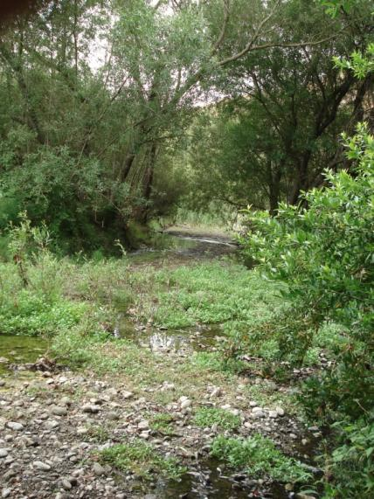
Photo #1: A view looking west (downstream) from the Eden Canyon Road/ Eden Canyon Creek junction showing the large stream bank silt deposits and open canopy creek course. 7/30/11
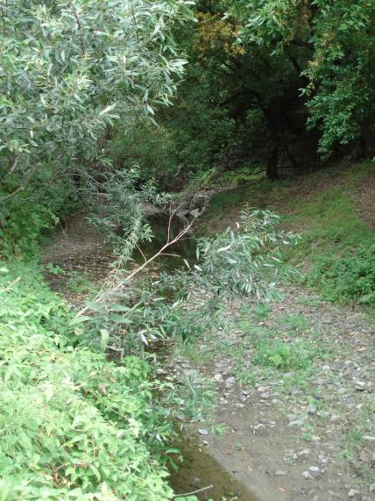
Photo #2: A view looking northeast (upstream) from the Eden Canyon Road/Eden Canyon Creek junction showing a relatively dense tree canopy and little silt deposition. 7/30/11

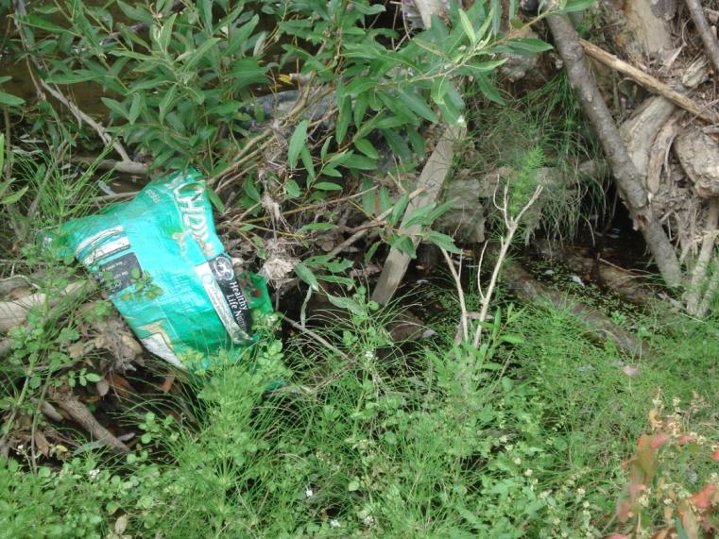
Photo #3: A plastic bag stranded two feet above the summer creek water level during high winter flows. A small side pool below it provides spawning habitat for Pacific chorus frogs and California newts. 7/30/11
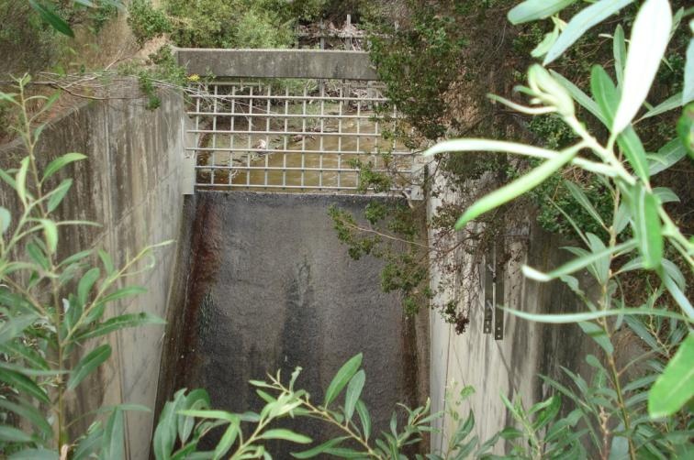
Photo #4: The formidable 15 foot high drop structure in the creek course just before it passes through a large culvert beneath Interstate 580. No fish or aquatic amphibian larvae can surmount this obstacle to reach the study area several hundred feet upstream. 8/6/11

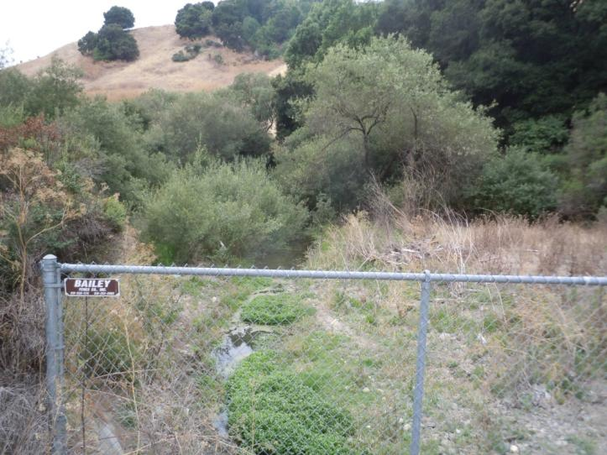
Photo #5: View of Eden Canyon Creek downstream toward the southwest. Photo taken from east end of box culvert on shoulder of Eden Canyon Road. Full width of Eden Canyon Creek up to normal high water mark is visible in photo. 8/6/11
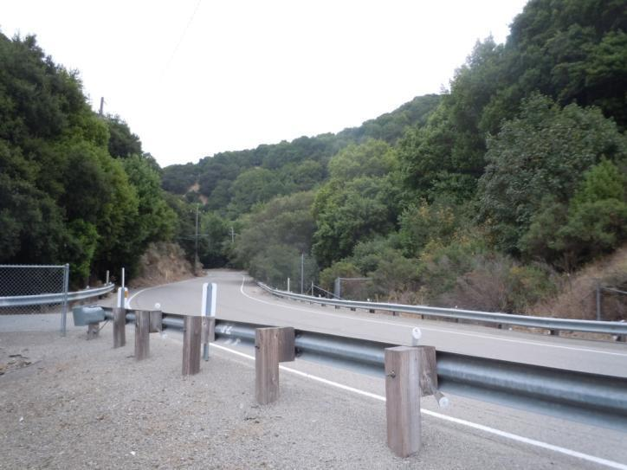
Photo #6: View across Eden Canyon Road upstream toward the north end of box culvert at fence. Photo taken from east end of box culvert on shoulder of Eden Canyon Road. 8/6/11

APPENDIX B

Special-Status Taxa Obtained With Database
Search With At Least Some Likelihood
Of Occurring In Or Near Site
APPENDIX B: Special-Status Taxa Obtained With Database Search With At Least Some Likelihood Of Occurring In Or Near Site
Scientific Name | Common Name | CDFG/CNPS Status | Federal/State  Status | Life form, bloom time,  habitat | Potential for occurrence in or near study area
Amsinckia lunaris | bent-flowered fiddleneck | 1B.2 |  | annual herb, Mar.-Jun.  cismontane woodland, valley & foothill grassland | Low. No nearby populations recorded. Would most likely occur in grasslands above riparian zone, if present in area.
Astragalus tener var. tener | alkali milk-vetch | 1B.2 |  | annual herb, Mar.-Jun.  (alkaline) valley & foothill grassland, vernal pools | Low. Area not alkaline in nature. Would most likely occur in grasslands above riparian zone, if present in area.
Atriplex joaquiniana | San Joaquin spearscale | 1B.2 |  | annual herb, Apr.-Oct.  (alkaline) valley & foothill grassland, meadows & seeps | Low. Area not alkaline in nature. Not observed and would be identifiable if present at time of survey.
Balsamorhiza macrolepis var. macrolepis | big-scale balsamroot | 1B.2 |  | perennial herb, Mar.-Jun.  chaparral, cismontane woodland, valley & foothill grassland | Moderate. Populations relatively close in all directions. Would most likely occur in grasslands above riparian zone, if present in area.
California macrophylla | round-leaved filaree | 1B.1 |  | annual herb, Mar.-May  (clay) cismontane woodland, valley and foothill grassland | Moderate. Relatively close populations to north and east. Would most likely occur in grasslands above riparian zone, if present in area.

APPENDIX B: Special-Status Taxa Obtained With Database Search With At Least Some Likelihood Of Occurring In Or Near Site
Scientific Name | Scientific Name | Scientific Name | Scientific Name | Scientific Name | Scientific Name
Calochortus pulchellus | Mt. Diablo fairy-lantern | 1B.2 |  | perennial bulb, Apr.-Jun.  chaparral, cismontane and riparian woodlands, valley and foothill grassland | Low. No extant populations as far south as the survey site, but cannot be excluded on the basis of this survey.
Centromadia parryi ssp. congdonii | Congdon's tarplant | 1B.2 |  | annual herb, May-Nov.  (alkaline) valley & foothill grassland | Low. Area not alkaline in nature. Not observed and would have been identifiable if present, at time of survey.
Delphinium californicum ssp. interius | HospitalCanyon larkspur | 1B.2 |  | perennial herb, Apr.-Jun.  chaparral openings, cismontane woodland, coastal scrub | Low. Generally, found on east side of coast ranges, 300 m or more elevation.
Didymodon norrisii | Norris' beard moss | 2.2 |  | moss  cismontane woodland, intermittently mesic | Possible, but not observed. Nearest population on record is Mt. Diablo.
Fritillaria liliacea | fragrant fritillary | 1B.2 |  | perennial bulb, Feb.-Apr.  (serpintinite) cismontane woodland, coastal scrub, valley & foothill grassland | Low. Site not serpentine in character and this species is generally found closer to the coast and/or further north.
Helianthella castanea | Diablo helianthella | 1B.2 |  | perennial herb, Mar.-Jun.  chaparral, cismontane and riparian woodlands, valley & foothill grassland, coastal scrub | Good. A number of populations relatively nearby, though at higher elevations. Would most likely occur in grasslands above riparian zone, if present in area.
Hesperolinon breweri | Brewer's western flax | 1B.2 |  | annual herb, May-Jul.  (serpentinite) chaparral, cismontane woodland, valley and foothill grassland | Low. Area is not serpentine in character and suitable habitat is not present.
Holocarpha macradenia | Santa Cruz tarplant | 1B.1 | T/E | annual herb, Jun.-Oct.  (clay, sandy) coastal scrub, valley and foothill grassland | Low. Very small number of populations that are more coastal and at lower elevations than study area.

APPENDIX B: Special-Status Taxa Obtained With Database Search With At Least Some Likelihood Of Occurring In Or Near Site
Scientific Name | Common Name | CDFG/CNPS Status | Federal/State  Status | Life form, bloom time, habitat | Potential for occurrence in study area
Juglans hindsii | Northern California black walnut | 1B.1 |  | perennial decid. tree, Apr.-May  riparian forest, riparian woodland | Good. None observed, though easily identifiable, if present, at the time of the survey.
Monardella villosa ssp. globosa | robust monardella | 1B.2 |  | perennial rhiz. herb, Jun.-Aug.  chaparral, cismontane woodland, coastal scrub, valley and foothill grassland | Good. None were observed, though easily identifiable if present, at the time of the survey.
Monolopia gracilens | woodland woollythreads | 1B.2 |  | annual herb, Feb.-Jul.  (serpentinite) chaparral, cismontane woodland, valley and foothill grassland | Low. Area is not serpentine in nature. Would most likely occur in grasslands above riparian zone, if present in area.
Streptanthus albidus ssp. peromoenus | most beautiful jewel flower | 1B.2 |  | annual herb, Mar.-Oct.  (serpentinite) chaparral, cismontane woodland, valley and foothill grassland | Low. Area is not serpentine in nature. Would most likely occur in grasslands above riparian zone, if present in area.
Stuckenia filiformis | slender-leaved pondweed | 2.2 |  | perennial rhiz. herb, May-Jul.  marshes and swamps | Low. Stream flow in winter at this site is likely too fast. Would have been identifiable, if present, at the time of the survey.
Trifolium hydrophilum | saline clover | 1B.2 |  | annual herb, Apr.-Jun.  marshes and swamps, alkaline valley and foothill grassland, vernal pools | Low. Area is not alkaline in nature, nor are there vernal pools. This clover is very closely associated with alkaline soils/salt marshes.

APPENDIX C

Special-Status Taxa Obtained From Database
Search But With Little Or No Likelihood
Of Occurring In Or Near Site
APPENDIX C: Special-Status Taxa Obtained From Database Search But With Little Or No Likelihood Of Occurring In Or Near Site
Scientific Name | Common Name | CDFG/CNPS Status | Federal/State  Status | Life form, bloom time, habitat | Potential for occurrence in study area
Anomobryum julaceum | slender silver moss | 2.2 |  | moss  broadleaf upland forest and coniferous forests | Unsuitable habitat and not observed.
Arctostaphylos auriculata | Mt. Diablo manzanita | 1B.3 |  | perennial evergreen shrub, Jan.-Mar. chaparral sandstone, cismontane woodland | Not observed, would be identifiable at time of survey.
Arctostaphylos manzanita ssp. laevigata | Contra Costa manzanita | 1B.2 |  | perennial evergreen shrub, Jan.-Apr. rocky chaparral | Not observed, would be identifiable at time of survey.
Arctostaphylos pallida | pallid manzanita | 1B.1 | T/E | perennial evergreen shrub, Dec.-Mar. chaparral, cismontane woodland, coastal scrub | Very limited populations. Not observed, would be identifiable at time of survey.
Campanula exigua | chaparral harebell | 1B.2 |  | annual herb, May-Jun.  (serpentinite, talus) chaparral | Lack of suitable habitat.
Chloropyron maritimum ssp. palustre | Point Reyes bird's-beak | 1B.2 |  | annual herb, Jun.-Oct.  coastal salt marshes and swamps | Unsuitable habitat, not observed, and would be identifiable at time of survey.
Chorizanthe robusta var. robusta | robust spineflower | 1B.1 | E/- | annual herb, Apr.-Sep.  cismontane woodland | All populations coastal and not observed.
Clarkia franciscana | Presidio clarkia | 1B.1 | E/E | annual herb, May-Jul.  coastal scrub, serpentinite valley and foothill grassland | Unsuitable habitat and a very limited distribution which is more coastal

APPENDIX C: Special-Status Taxa Obtained From Database Search But With Little Or No Likelihood Of Occurring In Or Near Site
Scientific Name | Common Name | CDFG/CNPS Status | Federal/State  Status | Life form, bloom time, habitat | Potential for occurrence in study area
Dirca occidentalis | western leatherwood | 1B.2 |  | perennial decid. shrub, Jan.-Apr. chaparral, cismontane woodland, riparian forest and woodland. | Not observed, would be identifiable at time of survey.
Eriogonum luteolum var. caninum | Tiburon buckwheat | 1B.2 |  | annual herb, May-Sep.  (serpentine) valley & foothill grassland, chaparral, cismontane woodland, | Unsuitable habitat (area not serpentine), populations are coastal, and none observed.
Eriogonum truncatum | Mt. Diablo buckwheat | 1B.1 |  | annual herb, Apr.-Dec.  sandy soil, chaparral, coastal scrub, valley and foothill grassland | Very limited distribution -- only one population known, on Mt. Diablo. None observed and would be identifiable at time of survey.
Hoita strobilina | Loma Prieta hoita | 1B.1 |  | perennial rhiz. herb, May-Oct.  chaparral, cismontane and riparian woodlands (serpentinite, mesic) | No nearby populations. Not observed, and would be identifiable at time of survey.
Horkelia cuneata ssp. sericea | Kellogg's horkelia | 1B.1 |  | annual herb, Apr.-Sep.  maritime chaparral | Not suitable habitat.
Lasthenia conjugens | Contra Costa goldfields | 1B.1 | E/- | annual herb, Mar.-June  cismontane woodland, vernal pools, valley grassland | All extant populations well north and east, habitat not suitable.
Malacothamnus hallii | Hall's bush-mallow | 1B.2 |  | perennial evergreen shrub, May-Oct., chaparral, coastal scrub | Not observed, would be identifiable at time of survey.
Meconella oregana | Oregon meconella | 1B.1 |  | annual herb, Mar.-Apr.  coastal scrub | Very limited distribution mostly coastal and distant from site.

APPENDIX C: Special-Status Taxa Obtained From Database Search But With Little Or No Likelihood Of Occurring In Or Near Site
Scientific Name | Common Name | CDFG/CNPS Status | Federal/State  Status | Life form, bloom time, habitat | Potential for occurrence in study area
Phacelia phacelioides | Mt. Diablo phacelia | 1B.2 |  | annual herb, Apr.-May  rocky cismontane woodland, chaparral | Not suitable habitat - minimum elevation 500 m.
Plagiobothrys diffusus | San Francisco popcorn-flower | 1B.1 | -/E | annual herb, Mar.-Jun.  valley and foothill grassland | Extant populations are coastal and not nearby.
Polemonium carneum | Oregon polemonium | 2.2 |  | perennial herb, Apr.-Sep.  coastal scrub | Habitat likely not suitable. Would have been identifiable at time of survey, not observed.
Sanicula maritima | adobe sanicle | 1B.2 | -/Rare | perennial herb, Feb.-May  chaparral, valley & foothill grassland | Populations all coastal, none nearby.
Sueada californica | California seablite | 1B.1 | E/- | perennial evergreen shrub, May-Oct., coastal salt marshes and swamps. | All extant populations coastal, not observed. though identifiable at time of survey.
Triquetrella californica | coastal triqetrella | 1B.2 |  | moss  coastal scrub | All extant populations coastal.  Not observed.
Viburnum ellipticum | oval-leaved viburnum | 2.3 |  | perennial deciduous. shrub  May-June, cismontane woodland, chaparral | Identifiable at time of survey and not observed.

APPENDIX D

Special-Status Wildlife Species Obtained From
Database/Literature With Potential To Occur
In Project Region
APPENDIX D: Special-Status Wildlife Species Obtained From Database/Literature With Potential To Occur In Project Region
Species | Status |  | Habitat Association | Potential for occurrence in the study area
 | Federal | State
Invertebrates
Linderiella occidentalis  California linderiella | FRT | -- | Seasonal pools in unplowed grasslands with old alluvial soils underlain by hardpan or in sandstone depressions. | No suitable habitat present.
Euphydryas editha bayensis  Bay checkerspot butterfly | FT | -- | Restricted to native grasslands on outcrops of serpentine soil in the vicinity of San Francisco Bay. Plantago erecta is the primary host plant, Orthocarpus densiflorus and O. purpurescens are the secondary host plants. | No suitable habitat present.
Fish
Eucyclogobius newberryi  Tidewater goby | FE | SC | Brackish water habitats along the California Coast from San Diego north to the mouth of the Smith River in Del Norte County. | No suitable habitat present.
Oncorhynchus mykiss  Steelhead -Central California Coastal ESU (DPS) | FT | -- | Requires beds of loose, silt-free, well-oxygenated coarse gravel for spawning. After hatching, juveniles spend at least one summer in the freshwater rearing areas, so the stream must have either perennial flow or cool intermittent pools with subsurface flow, shade, food, and shelter during the dry season. | Not likely to occur. A 15 ft high drop structure in the creek beneath I-580 is an in stream barrier that prevents access to the study area.
Amphibians
Ambystoma californiense  California tiger salamander | FT | ST | Need underground refuges, especially ground squirrel burrows and vernal pools or other seasonal water sources for breeding. | No suitable habitat present.
Rana boylii  Foothill yellow-legged frog | FSC | SC | Partly-shaded, shallow streams and riffles with a rocky substrate in a variety of habitats. Need at least some cobble-sized substrate for egg laying. | No suitable habitat in the form of deep pools and silt free rock rubble present.
Rana aurora draytonii  California red-legged frog | FT | SC | Occurs in a variety of ponds, sloughs, low-gradient streams, and low-salinity lagoons. Adults may forage in, and migrate through, terrestrial grasslands, riparian woodlands, and forests, but require weedy, slow moving or standing water that persists through most of the dry season for successful reproduction. Introduced bullfrogs and predatory fish are implicated in the decline of red-legged frogs throughout their range. | Low potential. No suitable breeding habitat in the form of deep pools. Could disperse through study area.
Reptiles
Emys marmorata  Western pond turtle | FUR | SC | Ponds, marshes rivers, streams, and irrigation ditches that have emergent or riparian vegetation and sunny basking sites. Upland nesting habitat consists of friable soil exposed to full sun. | Low potential. No suitable habitat in the form of deep pools and fish prey present; however this species could disperse through the study area.
Masticophis lateralis euryxanthus  Alameda whipsnake | FT | ST | Typically found in chaparral and scrub habitats but will also use adjacent grassland, oak savanna and woodland habitats. Mostly south-facing slopes and ravines, with rock outcrops, deep crevices or abundant rodent burrows. | Low potential. No suitable habitat in the form of open canopy coastal scrub present; however this species could disperse through the study area.
Birds
Phalacrocorax auritus  Double-crested cormorant | FSC | -- | Colonial nester on coastal cliffs, offshore islands, and along lake margins in the interior of the state. | No suitable habitat present.
Ardea herodias  Great blue heron | FSC | -- | Colonial nester in tall trees, cliffsides, and sequestered spots on marshes. Rookery sites in close proximity to foraging area: marshes, lake margins, tide-flats, rivers and streams, wet meadow. | No suitable habitat present.
Nycticorax nycticorax  Black-crowned night heron | FSC | -- | Colonial nester, usually tall trees, occasionally in tule patches. Rookery sites located adjacent to foraging areas: lake margins, mud-bordered bays, marshy spots. | No suitable habitat present.
Circus cyaneus  Northern harrier | FSC | SC | Coastal salt and freshwater marsh. Nest built of a large mound of sticks in wet areas. | No suitable habitat present.
Elanus leucurus  White-tailed kite | FSC | FP | Rolling foothills and valley margins with scattered oaks and river bottomlands or marshes nest to deciduous woodland. Open grasslands, meadows or marshes for foraging close to isolated, dense-topped trees for nesting and perching. | Suitable nesting habitat present.
Accipiter striatus  Sharp-shinned hawk | FSC | -- | Ponderosa pine, black oak, riparian deciduous mixed conifer and Jeffrey pine habitats; prefers riparian areas. | Suitable nesting habitat present.
Accipiter cooperii  Cooper’s hawk | FSC | -- | Woodlands, chiefly of open, interrupted or marginal type. Nest sites mainly in riparian growths of deciduous trees, as in canyon bottoms, on river flood-plains; also live oaks. | Suitable nesting habitat present.
Aquila chrysaetos  Golden eagle | FSC | -- | Rolling foothills, mountain areas, sage-juniper flats and deserts. Cliff-walled canyons provide nesting habitat in most parts of range; also large trees in open areas. | No suitable habitat present.
Falco mexicanus  Prairie falcon | FSC | -- | Inhabits dry, open terrain, either level or hilly. Breeding sites located on cliffs. Forages far afield, even to marshlands and ocean shores. | No suitable habitat present.
Rallus longirostris obsoletus  California clapper rail | FE | SE | Saltwater and brackish marshes traversed by tidal sloughs in the vicinity of San Francisco Bay. | No suitable habitat present.
Laterallus jamaicensis coturniculus  California black rail | FSC | ST | Inhabits freshwater marshes, wet meadows and shallow margins of saltwater marshes bordering larger bays. | No suitable habitat present.
Charadrius alexandrinus nivosus  Western snowy plover | FT | SC | Sandy beaches, salt pond levees and shores of large alkali lakes. Needs sand, gravelly or friable soils for nesting. | No suitable habitat present.
Sternula antillarum browni  California least tern | FE | SE | Nests along the coast from San Francisco Bay south to northern Baja California. Colonial breeder on bare or sparsely vegetated, flat substrates: sand beaches, alkali flats, land fills or paved areas. | No suitable habitat present.
Rynchops niger  Black skimmer | FSC | SC | Nests on gravel bars, low islets, and sandy beaches, in unvegetated sites. Nesting colonies usually less than 200 pairs. | No suitable habitat present.
Asio flammeus  Short-eared owl | FSC | SC | Found in swamp lands, both fresh and salt; lowland meadows; irrigated alfalfa fields. | No suitable habitat present.
Athene cunicularia  Burrowing owl | FSC | SC | Open, dry annual or perennial grasslands, deserts, and scrublands characterized by low-growing vegetation. Subterranean nester, dependent upon burrowing mammals, most notably, the California ground squirrel. | No suitable habitat present.
Eremophila alpestris actia  California horned lark | FRT | -- | Coastal regions, chiefly from Sonoma County to San Diego County. Also main part of San Joaquin Valley and east to foothills. Nests in short-grass prairie, bald hills, mountain meadows, open coastal plains, fallow grain fields, and alkali flats. | No suitable habitat present.
Riparia riparia  Bank swallow | FSC | ST | Colonial nester, nests primarily in riparian and other lowland habitats west of the desert. Requires vertical banks/cliffs with fine textured/sandy soils near streams, rivers, lakes, ocean to dig nesting holes. | No suitable habitat present.
Dendroica petechia brewsteri  Yellow warbler | FSC | SC | Riparian plant associations. Prefers willows, cottonwoods, aspens, sycamores, and alders for nesting and foraging. | Suitable nesting habitat is present.
Geothlypis trichas sinuosa  Saltmarsh common yellowthroat | FSC | SC | Resident of the San Francisco bay region, in fresh and saltwater marshes. | No suitable habitat present.
Melospiza melodia pusillula  Alameda song sparrow | FSC | SC | Resident of salt marshes bordering south arm of San Francisco Bay. | No suitable habitat present.
Agelaius tricolor  Tricolored blackbird | FRT | SC | Highly colonial species, most numerous in Central Valley and vicinity. Largely endemic to California. Requires open water, protected nesting substrate, and foraging area with insect prey within a few km of the colony. | No suitable habitat present.
Mammals
Sorex vagrans halicoetes  Salt-marsh wandering shrew | FSC | SC | Salt marshes of the south arm of San Francisco Bay. | No suitable habitat present.
Myotis yumanensis  Yuma myotis | FSC | -- | Optimal habitats are open forests and woodlands with sources of water over which to feed. Distribution is closely tied to bodies of water. Maternity colonies in caves, mines, buildings or crevices of bridges, rocks, and trees. | Suitable habitat present in the form of crevices in trees and hollow trees. The nearest CNDDB record (occurrence 78) is for several adult bats leaving a bridge roost site approximately 5.4 miles east of the study area near Foothill Road near the Dublin/Pleasanton border..
Lasionycteris noctivagans  Silver-haired bat | FSC | -- | Maternity roosts inside hollowed trees, bird excavated cavities, under loose bark of large diameter hollowed snags. Forage above tree canopies, over open meadows and in riparian zones (Perkins 2005). | Suitable habitat present in the form of crevices in trees and hollow trees.
Antrozous pallidus  Pallid bat | FSC | SC | Roosts in caves, mine tunnels, crevices in rocks, bridges, buildings, and hollowed trees. | Suitable habitat present in the form of crevices in trees and hollow trees.
Eumops perotis californicus  Western mastiff bat | FSC | SC | Primarily a cliff dwelling species with maternity roosts under exfoliating rock slabs, and crevices in large boulders and buildings. Foraging habitat includes dry desert washes, flood plains, chaparral, oak woodland, open ponderosa pine forest, grassland and agricultural areas (Siders 2005). | No suitable habitat present.
Taxidea taxus  American badger | FSC | SC | Dry open stages of most shrub, forest and herbaceous habitats with friable soils. | No suitable habitat present.
Vulpes macrotis mutica  San Joaquin kit fox | FE | ST | Annual grasslands or grassy open stages with scattered shrubby vegetation. Need loose-textured sandy soils for burrowing, and suitable prey base. | Not likely to occur. This species occurs predominately in the Central Valley. The nearest CNDDB record (occurrence 1031) is for a fox observed near Tassajara Creek Regional Park about 7.9 miles east of the study area.
Dipodomys heermanni berkeleyensis | FSC | -- | Open grassy hilltops and open spaces in chaparral and blue oak/digger pine woodlands. | No suitable habitat present.
Reithrodontomys raviventris  Salt-marsh wandering shrew | FE | SE | Only in the saline emergent wetlands of San Francisco Bay and its tributaries. Pickleweed is primary habitat do not burrow, build loosely organized nests require higher areas for flood escape. | No suitable habitat present.

Status Legend for Listed Wildlife for Appendix B through D

Federal:
FE Listed as endangered under the Federal Endangered Species Act
FT Listed as threatened under the Federal Endangered Species Act
FRT Listed as rare/threatened under the Federal Endangered Species Act
FUR Listed as uncommon/rare under the Federal Endangered Species Act
FSC Species of Concern - A species under consideration for listing, for which there is insufficient information to support listing at this time

State:
SE Listed as endangered under the California Endangered Species Act
ST Listed as threatened under the California Endangered Species Act
SC Species of special concern under the California Endangered Species Act

California Native Plant Society:
1B Rare, threatened or endangered in California
2 Rare, threatened or endangered in California
3 More information needed regarding occurrences

